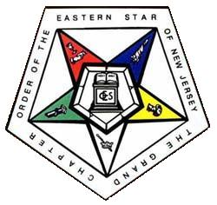

GRAND CHAPTER
ORDER OF THE EASTERN STAR OF NEW JERSEY
111 Finderne Avenue, Bridgewater
New Jersey 08807-3101
Phone: (908) 725-0222 / 0232 Fax: (908) 725-4053
E-mail: njoesgc@optonline.net Web Site: www.njoes.com

Name: Date:
Address:

QTY DESCRIPTION AMOUNT

Make check out to: Grand Chapter OES of NJ Thank You

_______________________ Chapter No. ____

