SUNSET AND SMILES
ON THE
RIVER LADY
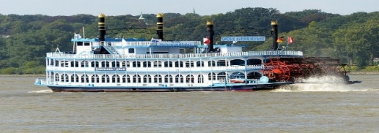
DINNER CRUISE
1 ROBBINS PARKWAY, TOMS RIVER N.J.
AUGUST 11,2026 6 O’CLOCK TO 8:30 PM
UPPER DECK (OPEN) FIRST 50 REQUEST
LOWER DECK (AIR CONDITION) 70
DINNER CHOICE
CHICKEN FRANCESE
CHICKEN MARSALA
FILET OF SALMON
EGGPLANT PARMESAN
PENNE VODKA
CASH BAR
$65 PER PERSON OPEN TO FAMILY AND FRIENDS
CHECKS MADE OUT TO VOLUNTARY DONATIONS
MAILED TO CATHY FUSARO 1241B THORNBURY LANE MANCHESTER NJ 08759
Deadline July 25,2026
Email fusarocathy 22@gmail.com
732-598-8738
5:30 BOARDING BOAT LEAVING 6 O’CLOCK SHARP
USE PARKING DECK ACROSS THE STREET

RIVER LADY

NAME(s)……………………………………………………………………………………………………………..
EMAIL……………………………………………………………………………………………………………….
PHONE……………………………………………………………………………………………………………..
DINNER CHOICE…………………………………………………………………………………………………
DECK……………………………………………………………………………………………………………….
.
IF POSSIBLE SIT WITH……………………………………………………………………………………

