Pop-up Gown Boutique
Saturday, September 20, 2025
9:00am – 2:00pm
Benefitting the NJ Eastern Star Home
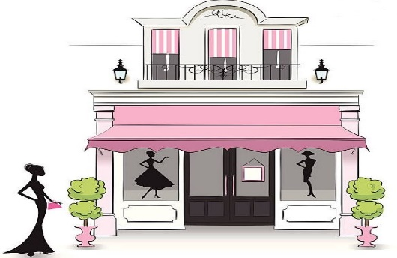
Molly Pitcher Chapter #198
2 Dutch Lane Road
Freehold, NJ 07726
Womens Formal Gowns, Tops, Skirts, Shoes & Accessories
Mens Tuxedos, Suits, Dress Shirts, Vests, Ties & Shoes
Everything on sale for $5.00
Due to limited storage space, it is requested Donations be brought to the lodge building on the morning of the Boutique on Sept. 20, 2025
Formalwear (long) & Black-tie attire ONLY. Gently used or worn, current style Adult clothing, shoes & accessories of less than 10 years aged from non-smoking environments.
Please launder clothing in advance of donating. Provide on hangers if possible. NO casual clothing/shoes, short dresses/skirts, sport coats, mens suit jackets/pants without matching piece, outerwear coats/jackets, hosiery, socks, undergarments, gloves, hats, scarves, belts, pocket squares, slippers, boots, OES/Masonic household items, Chapter/Lodge paraphernalia, souvenirs, gift pins, personalized or Chapter/Lodge name identified items.

Join these events also taking place at Molly Pitcher Chapter #198 on Sept. 20, 2025
State Secretary & Treasurers Meeting 10am - 12noon
Contact Patti Rhinesmith for details & reservations (201)390-3563, crystalpatti3@aol.com
Past Matrons & Past Patrons Association Meeting – Luncheon @ 12pm, Meeting @ 1pm – 3pm
Contact Michele Hess for details and lunch reservations (973)390-1250, hessm902@aol.com

