Dear Family, Friends, and Fellow Chapters,

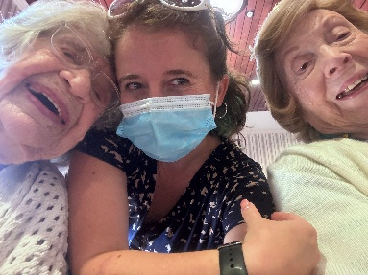We hope you are all doing well and enjoying your summer season. On behalf of our residents, my team, and myself we would like to thank you for your continued generosity and support to our community. Boutique donations, birthday bags, volunteering, and more, everything is truly appreciated. Your thoughtfulness and efforts are making a bigger differences than words can express.

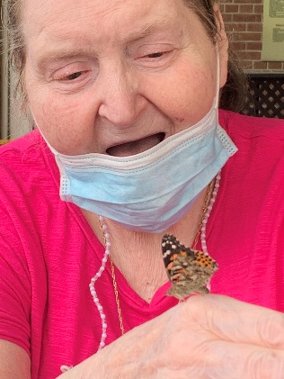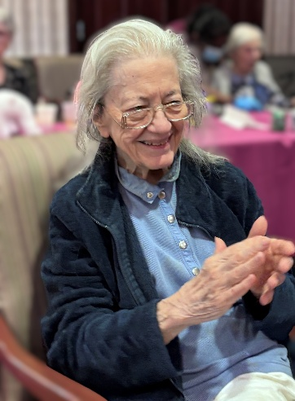Your dedication to our facility is truly valued. Your support has allowed us to create a wide range of engaging and meaningful activities that allow our residents to explore their interests and develop their personal strengths. So far this year we have been able to organize a wider range of programming for our residents including of course a community favorite bingo, as well as, our monthly boutique. From community youth choir concerts, our Pink Ladies Club, as well as, our Gentlmens Club we have expanded the programs we offer to provide meaningful and engaging programs for all residents and patients who come to our home.

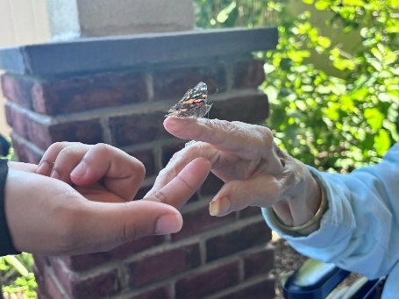Additionally, we have been coordinating monthly birthday celebrations to honor and recognize our residents on their special day. Also, this year we enjoyed taking part in our 3rd Annual Butterfly program, where our residents learn about, track the growth, and release new butterflies into our community. This activity has truly become a facility favorite that our residents and staff look forward to taking part in every year. These are only a few examples of the various programs we have been able to organzie.

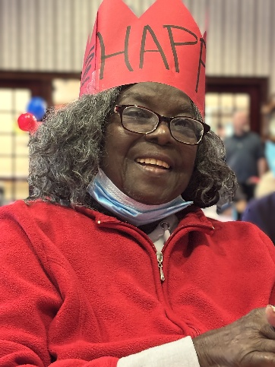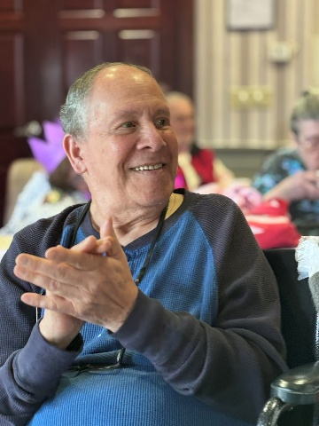I am reaching out to see if you would be willing to help me spread the word around the community to see if chapter members or community members would be interested and willing to organize programs with the residents and donate supplies to help enrich our seniors through programming and more as well as, to our monthly boutique. Our residents have been asking if Chapters would be interested in coming in to the facility to run program with them. They expressed that they greatly enjoyed their company and programs in the past and are looking forward to it hopefully in the near future.

If any Chapter is interested in organizing and running a program with our residents. I kindly ask that you contact me so we can coordinate the time, date, and specifics of our program.

Thanks for your time.

Kindly,

Simone Rudich

*Director of Activities*

New Jersey Eastern Star Home

908-722-4140 ext. 3527



**Boutique and Donation Items List**

Shampoo

Conditioner

Liquid Hand Soap

Perfume

Purses

Cologne

Watches

Clothing (New)

Yarn (Medium or Large Weight)

Crocheting Hooks

Large Print Reading Books in (Polish and Spanish Translation)

Wallets

Stamp Ink Pads

Word puzzle books

Makeup (Eyeshadow, Blush, Lipstick)

Stuffed Animals

Hair Accessories