
Faith, Family & Friends
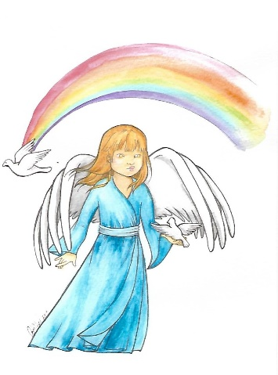
10 Year Reunion

You are warmly invited to gather for
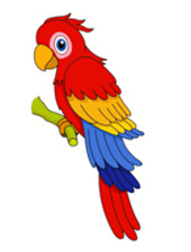

fellowship, food, and cherished memories.

Sunday September 27, 2026
2:00 PM Luncheon

Burlington Masonic Lodge
2308 Burlington-Mt Holly Rd.
Burlington, NJ 08016
Cost $15.00 Dues $5.00

Make Checks payable to
Cheryl Morris
19 Crestwood Ave.
Blackwood NJ 08012

Reservations by September 18, 2026

