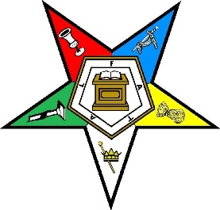

Haddonfield Chapter #140
Invites you to attend an Honor Night
On
Thursday, December 4th, 2025

Celebrating
Sister Kathleen Zielinski, Grand Representative of Mississippi
Sister Dawn Shellock, Grand Representative of Wisconsin
Sister Susan Sharpe-Corliss, Grand Representative of North Dakota

OES Members & Master Masons are invited to attend our meeting at 7:30 PM.

Guests who are not members of OES or Master Masons are invited to assemble in the Lodge’s parlor at 8 PM. We will welcome you to join us for the ceremony after our meeting has concluded.
Refreshments To Follow
Haddonfield Masonic Temple
16 Kings Highway E., Haddonfield, NJ 08033

